MHS Home and School Association
May Meeting Minutes
May 9th, 7pm Library

Attendees- Susan Demedio, Katie Shireman, Sophia Pham, Sandy Katz, Michelle Jackson-Greenwalt, Deanna Roeger, and Laura Kemp

MHS Reports:
Principal- Dr. Euker was not feeling well so Katie Shireman reported on her behalf. Katie shared that Keystones start on Monday. There are 3 hour delays on the 13,14, 20, and 21st of May. Teachers were very appreciative of pretzels supplied for teacher appreciation week from home and school and they thank us. Parents of juniors should check out the opportunities from CADY our new photography company. They are offering great opportunities to families. Check our newsletter and emails directly from CADY.
Teachers-Please see the attached below submitted from Andrea Borgmann
SENIOR CLASS TRIP  MAY 23  7:30 AM- 8:00 PM | The senior class trip is May 23rd from 7:30am -8pm at the Pocono Valley Resort.    Tickets will be going on sale starting around April 10th for $90.
SENIOR SUNSET  MAY 31  7-9PM | MHS will also be hosting a senior sunset for the senior class May 31st from 7-9pm which will be fully free for students.  There will be a DJ, food trucks, games and more.  Location: MHS Stadium  Donations for drinks and snacks are needed.
 | April 8-12:DIVERSITY AND INCLUSION WEEK  Monday: "Spread the Word...Inclusion"  Wear Blue or Black to help spread Inclusion awareness  · Sign the “Pledge for Inclusion” at all lunches  Tuesday: “We are Methacton!”  Wear Green or White to show that we may all be different in some ways, but we are all unified as a Methacton Community  Wednesday: "On Wednesdays We Wear Pink"  Wear your Pink and invite everyone to sit with you… at Methacton everyone is included  · Listen to the Warrior News about removing stereotypes  Thursday: "Cultural Pride Day"  Wear country colors, flag or traditional cultural garb as we honor our heritage and show our diversity  Friday: “Everything but a Backpack Day”  Carry your belongings using everything but a backpack  Sponsored by the following clubs: Unified, Best Buddies, Multicultural, Asian Student Association, BSU, GSA
MINITHON  NEWS | MINITHON RAISED $65,000 FOR CHILDREN’S CANCER CARE AND RESEARCH. YAY!!  
STEM DAY  APRIL 13  10-12:00 PM  MHS/GIRLS GYM  Our High School students will be performing engaging and interactive experiments for kids to enjoy. | 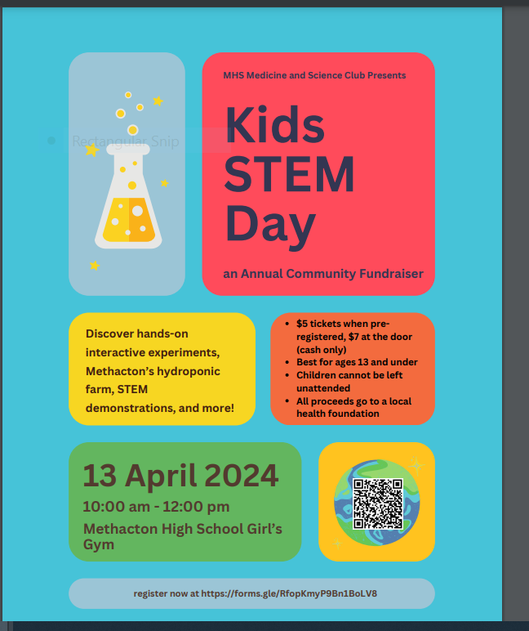
KIDS AGAINST CRISIS | 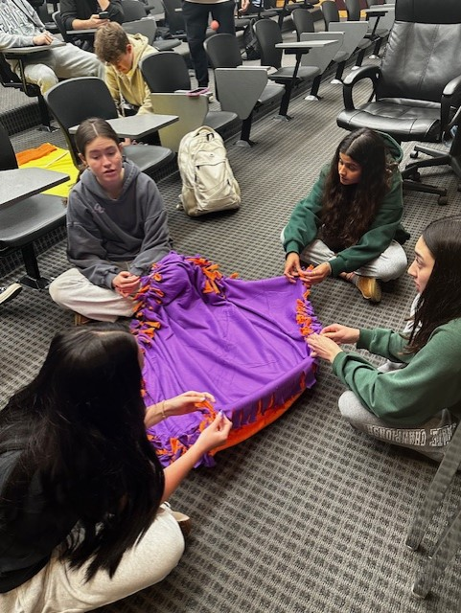  Students in KAC are making blankets for Project Linus. Project Linus provides handmade blankets to children 0-18 in the United States who are seriously ill, traumatized, or otherwise in need.
GIRLS LACROSSE  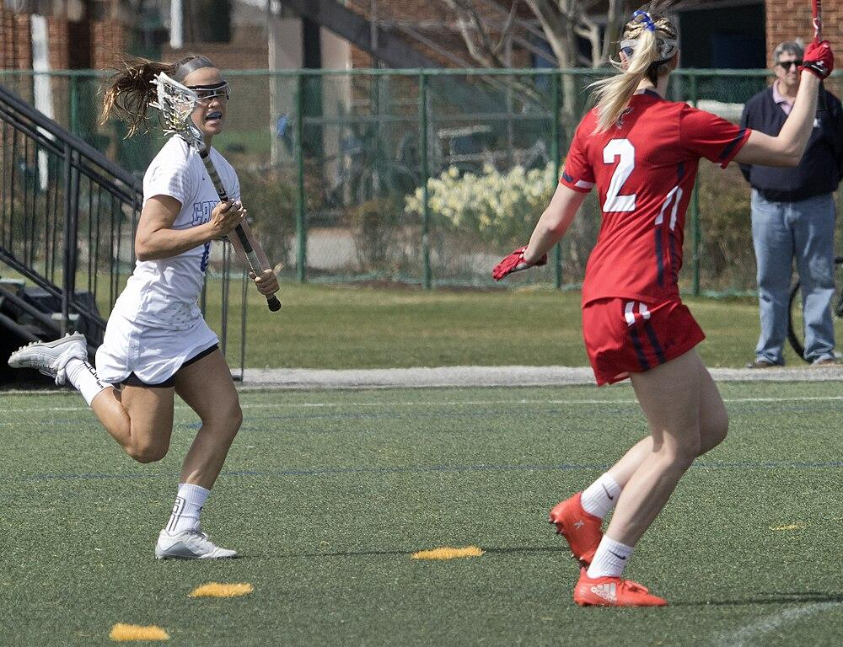 | On April 24,2024 the girls Lacrosse will have an Autism Awareness game.  Best Buddies will attend the game in support.  T-Shirts are available for pre-order.  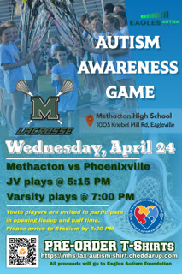
CARL KRALIK | Methacton Technology and engineering Education Department:  Intro to Engineering: The students used CAD to draw plans for a Tealight holder. We then cut out the plans using the Laser cutter. (Picture below)  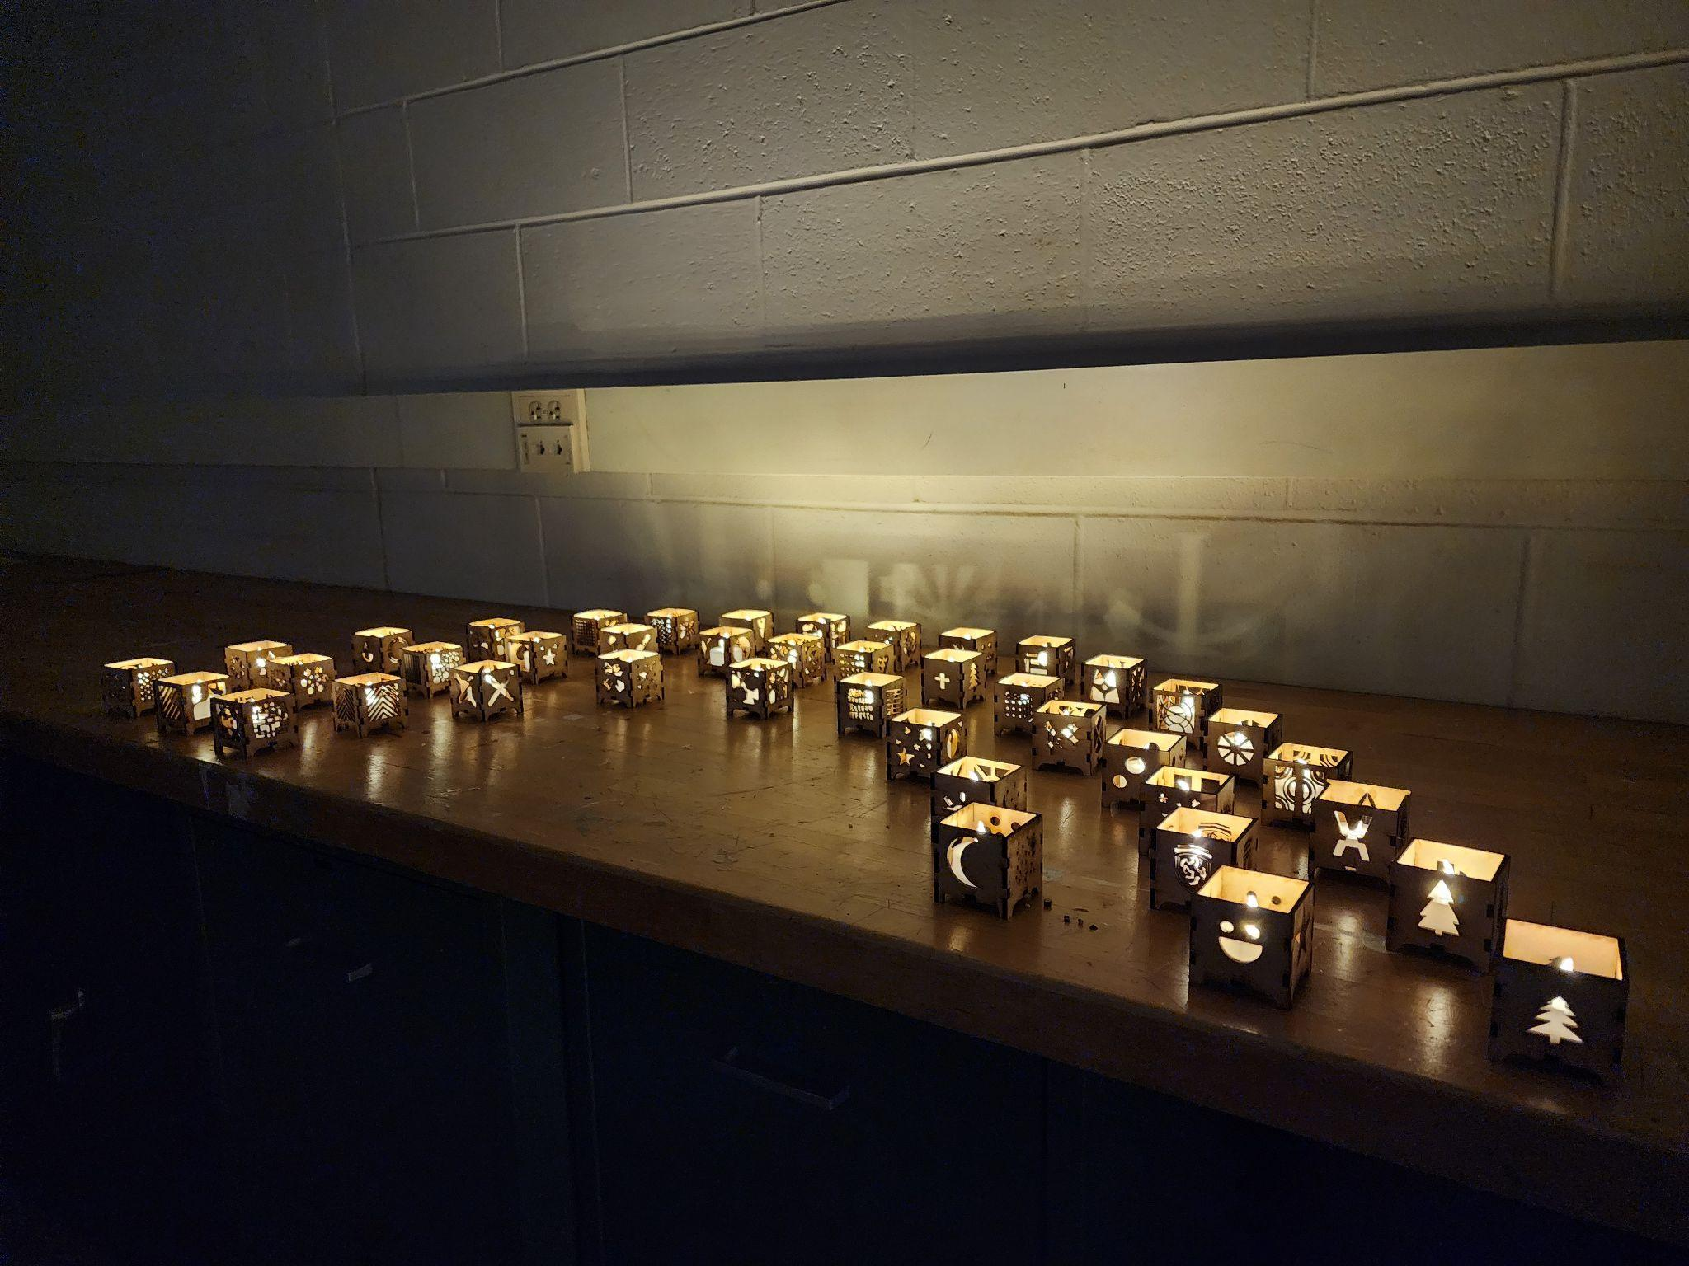  Architectural Design 2: Students just finished designing a 2 story house floor plan. Next they will learn how to create the exterior plans of the house.  Engineering Design 2: Students are working on engineering a small 3D printed vehicle that is battery powered.  3D Modeling and Printing: Students just created and presented business card holders our new principal Dr. Euker. (picture below)  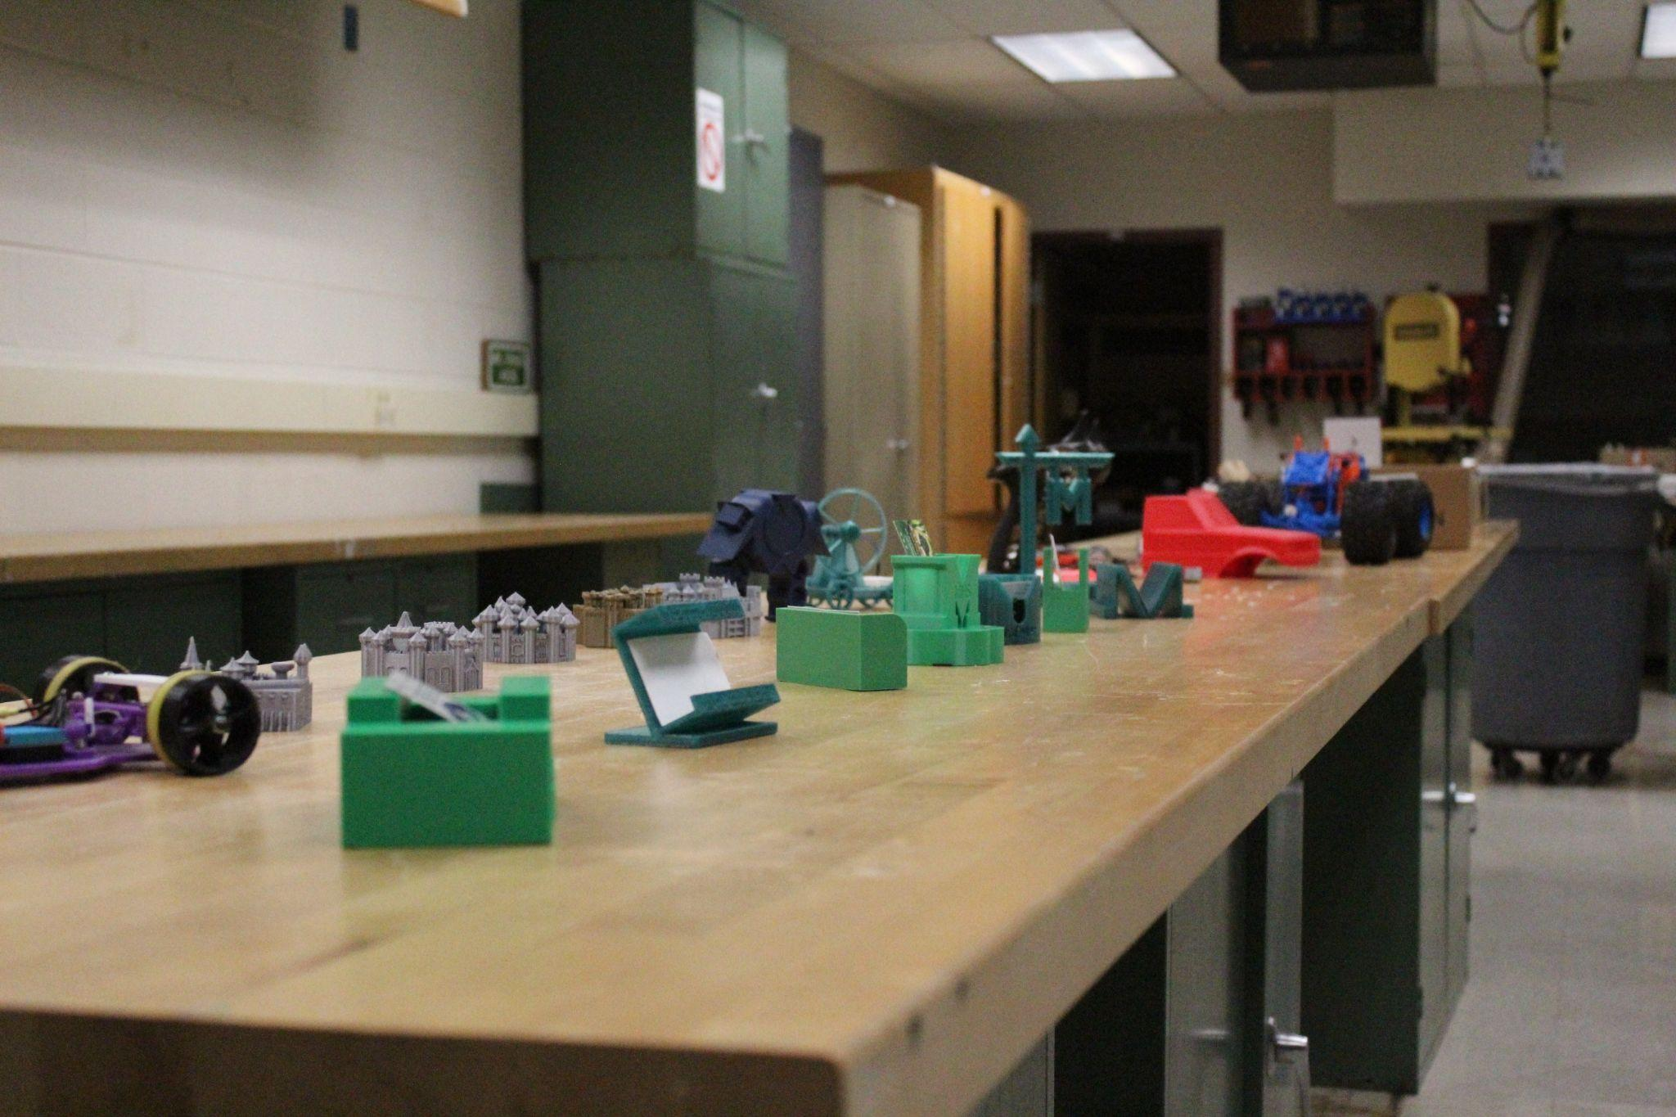
CAREER DAY | We had a very successful career day including a job fair, special visitors, games, a  beautiful senior video (posted in the Google Classroom)…… and well, we also had a surprise Earthquake. 
KINDNESS cART | Dr. Eucker in conjunction with the Art Dept. developed the concept of the Kindness cArt which will be available for teachers to use with their students.  The Kindness cArt can be signed out and rolled into any classroom within the High School.  The purpose of the Kindness cArt is to help promote collaboration, creativity, and a focus on empathy through art as a medium.
MR.  GALLAGHER   | Please congratulate the following students who returned from the Future Business Leaders of America State Competition in Hershey earning the following:  Dylan Wen - 2nd place, Insurance & Risk Management  Victoria Fan - 4th place, Business Communication  Max Wu - 1st place, Securities and Investments  These students will now have the opportunity to compete at the national level this summer in Orlando.
THANK YOU HOME AND SCHOOL | The Theatre Company had an exciting and fantastic run of our spring musical, Chicago: Teen Edition in March. We were able to put to good use the changing stalls we purchased with our H&S mini grant this fall, since we had so many students needing costume changes!  WPG is getting ready for our Spring Showcase, on Friday, April 26th at 7pm in the auditorium.  Both groups would like to thank Home & School for awarding us a mini grant to purchase a portable speaker, which has already been put to good use, and our shop vac and mic cart.  We are so appreciative of the support from our Home & School!

Counselors- No Report
President- Susan reported the winning warriors for the month were freshman Salem Gonzalez, sophomore Angel Rojas, Junior Mahammad Rathod, and senior Jules Carpia. She brought the class of 2024 pens to show as they all have come in and are very nice. She reported she had delivered the pretzels and all went well for teacher appreciation.
Vice President- Katie Shireman said the recipients for the Most Improved Award have come in and they will be awarded on May 22nd at 7pm at the awards ceremony.
Treasurer- Sophia Pham said they had $550 spent on mini-grants. We have $2062 left in the account. 2 mini-grants are left with about $250 left on that to pay out. Have the graduation parade snacks coming up (Katie will handle). Asked about the scholarship funds and Sue had papers she gave Katue Shireman to get to Dr. Euker to give to the staff member that may inherit the fund moving forward. She also passed out nice soap to those in attendance-Thanks Sophia!
Secretary-Susan shared that Heather Dewane was resigning her position.

District Reports:
SEA-Michelle reported. Please see the below link for all information
Stay Connected: May Special Education Alliance Newsletter (mailchi.mp)
Post Prom-Katie Shireman said it was the highest turnout in the past five years with 703 kids in attendance. Had some want to leave early but most were underclassmen as dates. Contemplating extending sensory time or incorporating time bands to ensure activities can be met before dismissal. Discussed the possibility of best buddies with future post proms. There was an injury in the last ten minutes on the inflatables but paramedics were called and the correct protocol was implemented and everyone was ok.
MCC- There will be a meeting this Monday night at 7m at the high school.

May
13,14,20,21- Keystone testing
22- Yearbook Breakfast
24- No School Inservice
27-No School (holiday)

June
1 SATS
3, 4, 5- Senior Class Final Exams
6,7,10, 11- Underclassman Final Exams
7- Graduation Practice
10- Graduation Practice and Parade
11- Graduation Practice
11- Commencement
12- Last Day/4th Marking Period Ends

